H.T No
Regulations:
A22

Sreenidhi Institute of Science and Technology
(An Autonomous Institution)
Code No:9AC48 Date: 17-August-2024 (FN)

B.Tech II-Year II- Semester External Examination, August-2024 (Regular)
BASIC ELECTRICAL AND ELECTRONICS ENGINEERING(CIVIL and MECHANICAL)

Time: 3 Hours Max.Marks:60

Note: a) No additional answer sheets will be provided.
b) All sub-parts of a question must be answered at one place only, otherwise it will not be valued.
c) Missing data can be assumed suitably.
Bloom's Cognitive Levels of Learning (BCLL)

Remember | L1 | Apply | L3 | Evaluate | L5
Understand | L2 | Analyze | L4 | Create | L6

Part - A Max.Marks: 6x2=12

Answer all QUESTIONS, EACH QUESTION CARRIES 2 MARKS.

 |  | BCLL | CO(s) | Marks
1 | State Kirchhoff’s laws. | L1 | CO1 | [2M]
2 | Define peak factor and form factor. | L1 | CO2 | [2M]
3 | Discuss the advantages of MI instrument. | L3 | CO3 | [2M]
4 | List the applications of PN junction diode. | L1 | CO4 | [2M]
5 | State any four uses of JFET. | L2 | CO5 | [2M]
6 | Convert (13.65625)₁₀ into binary equivalent number. | L2 | CO6 | [2M]

Part – B Max.Marks: 6x8=48
ANSWER ALL QUESTIONS. EACH QUESTION CARRIES 8 MARKS.

 |  | BCLL | CO(s) | Marks
7. | Calculate the value of current in 10Ω by using nodal analysis for the following circuit.  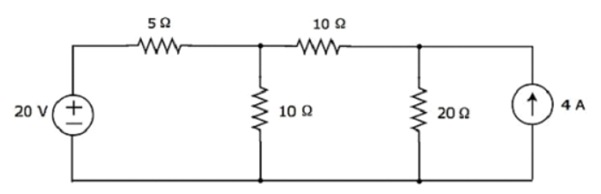 | L3 | CO1 | [8M]
 | OR
8 | Determine the voltage generated for a 4-pole DC generator for both wave winding and lap winding where armature winding has 61 slots, each slot has 15 conductors when driven at 1500 r.p.m assuming flux per pole is 6 m Wb | L5 | CO1 | [8M]
9. | Explain circuits of (i) Series R-L circuit (ii) Series R-C circuit with neat diagram. | L6 | CO2 | [8M]
 | OR
10 | A pure inductance coil allows a current of 15A to flow from a 230V,50Hz supply. Determine (i) Inductive Reactance (ii) inductance of the coil (iii) Power absorbed in the coil | L5 | CO2 | [8M]
11 | Describe how rotating magnetic developed in 3-phase induction motor and write the expression for resultant mmf. | L1 | CO3 | [8M]
 | OR
12 | Explain the construction and working principle of PMMC instrument with neat Sketch. | L2 | CO3 | [8M]
13 | a) Discuss the operation of clampers.  b) Describe the characteristics of PN junction diode with a neat sketch. | L2  L1 | CO4 | [8M]
 | OR
14 | - a) Explain about Zener break down and Avalanche breakdown  - b) Describe how Zener diode can be used as voltage regulator with neat circuit diagram. | L2  L1 | CO4 | [8M]
15 | Explain the drain and transfer characteristics of MOSFET in depletion mode with neat sketches, necessary equations. | L6 | CO5 | [8M]
 | OR
16 | Explain the working of a P channel JFET with neat sketch and draw the V-I characteristics of it. | L6 | CO5 | [8M]
17 | a) Determine K-map for the following the function F (A, B, C, D) = Σ (0, 1, 3, 4, 6, 8, 15)  b) Convert i) (22.78)₈ into decimal ii) (11010.101)₂ into decimal | L5  L2 | CO6 | [8M]
 | OR
18 | a) Discuss various logic gates with truth tables.  b) Explain binary arithmetic with examples. | L6  L2 | CO6 | [8M]

-- 00 -- 00 –

